Jenkins -04
1) Setup jenkins CICD pipeline using freestyle job using Docker containers using below code.
https://github.com/betawins/hiring-app.git
Stages:
1) Git Clone
2) Sonarqube Integration
3) Maven Compilation
4) Nexus Artifactory
5) Slack Notification
6) Deploy On tomcat
2) Setup a jenkins CICD pipeline using Declarative pipeline using feature-1.1 branch.
https://github.com/betawins/sabear_simplecutomerapp/tree/feature-1.1
stages:
1) Git Clone
2) Sonarqube Integration
3) Maven Compilation
4) Nexus Artifactory
5) Slack Notification
6) Deploy On tomcat
3) Setup a jenkins CICD pipeline using Scripted pipeline using feature-1.1 branch.
https://github.com/betawins/sabear_simplecutomerapp/tree/feature-1.1
stages:
1) Git Clone
2) Sonarqube Integration
3) Maven Compilation
4) Nexus Artifactory
5) Slack Notification
6) Deploy On tomcat
4) Write sample skeleton of pipelines.
5) Create a parametirized job in jenkins.
https://github.com/betawins/spring3-mvc-maven-xml-hello-world-1.git
6) Setup one slave machine for jenkins.
GitHubGitHub
GitHub - betawins/hiring-app
Contribute to betawins/hiring-app development by creating an account on GitHub. (33 kB)
https://github.com/betawins/hiring-app.git

GitHubGitHub
GitHub - betawins/sabear_simplecutomerapp at feature-1.1
Contribute to betawins/sabear_simplecutomerapp development by creating an account on GitHub. (34 kB)
https://github.com/betawins/sabear_simplecutomerapp/tree/feature-1.1

GitHubGitHub
GitHub - betawins/spring3-mvc-maven-xml-hello-world-1: Maven + Spring 3 MVC hello world example (XML)
Maven + Spring 3 MVC hello world example (XML). Contribute to betawins/spring3-mvc-maven-xml-hello-world-1 development by creating an account on GitHub. (51 kB)
https://github.com/betawins/spring3-mvc-maven-xml-hello-world-1.git

1) Setup jenkins CICD pipeline using freestyle job using Docker containers using below code.
https://github.com/betawins/hiring-app.git
Stages:
1) Git Clone
2) Sonarqube Integration
3) Maven Compilation
4) Nexus Artifactory
5) Slack Notification
6) Deploy On tomcat

- GIT CLONE and 2. SONARQUBE INTEGRATION
a. Installed jenkins in jenkins-ec2 take t2.large
b. Created sonarqube-ec2 take t2.large and installed docker and pull image of
sonarqube.
yum -y install docker
systemctl start docker
docker pull sonarqube
docker run -d --name sonarqube -p 9000:9000 sonarqube:lts
Docker ps
d. In jenkins master install sonarqube-scanner plugin
Go to Manage Jenkins → System.
Scroll to SonarQube servers section.
Add:
● Name → SonarQube
● Server URL → your SonarQube URL (example: http://<sonarqube-
server-ip>:9000)
● Authentication Token → generate one in SonarQube (My Account →
Security → Tokens).
e. Now in jenkins home page, create a job hiring-app and enter the analysis properties
f. https://github.com/betawins/hiring-app.git
g. The repo is in main branch same need to configure in job also.

sonar.projectKey=Sabear
sonar.projectName=Sabear
sonar.projectVersion=1.0
sonar.sources=/var/lib/jenkins/workspace/$JOB_NAME/src/
sonar.binaries=target/classes/com/visualpathit/account/controller/
sonar.junit.reportsPath=target/surefire-reports
sonar.jacoco.reportPath=target/jacoco.exec
sonar.java.binaries=src/main/java/com/visualpathit/account/

Now Start
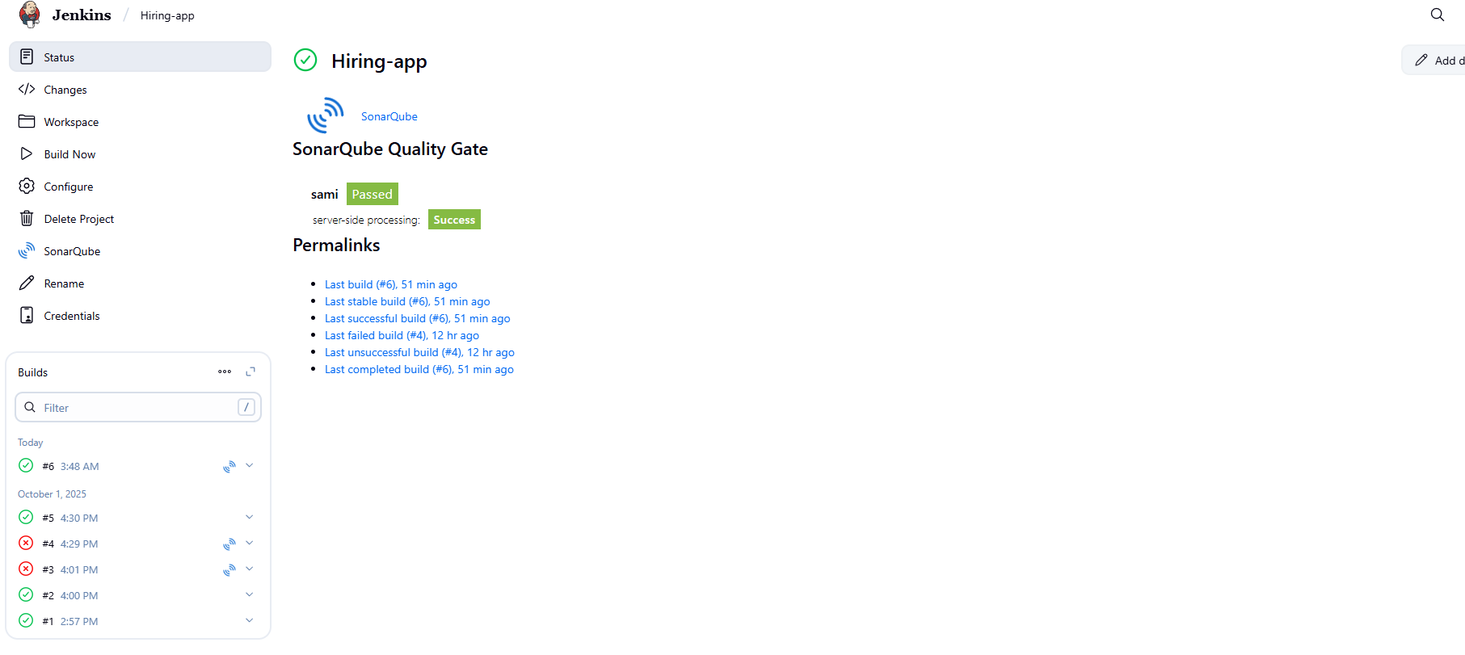
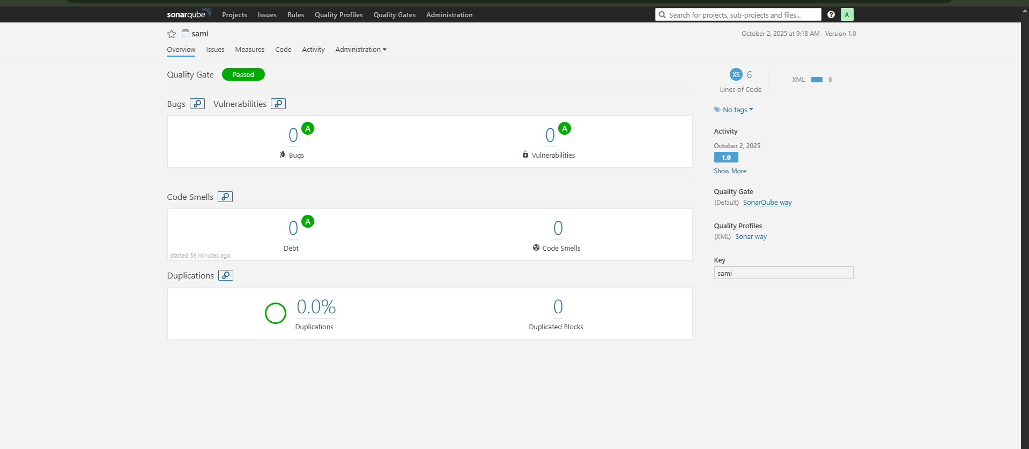

MAVEN COMPILATION
Now install Maven in Jenkins Server
Now extract the tar file
tar -xvf apache-maven-3.9.11-bin.tar.gz
cd apache-maven-3.9.11/bin
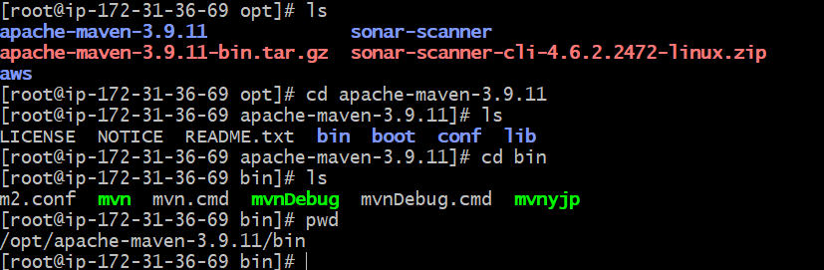
store global variable in script to access maven –version
In jenkins server edit the file and some details → vi .bash_profile
MVN_HOME=/opt/apache-maven-3.9.11/bin
PATH=$PATH:$HOME/bin:$MVN_HOME
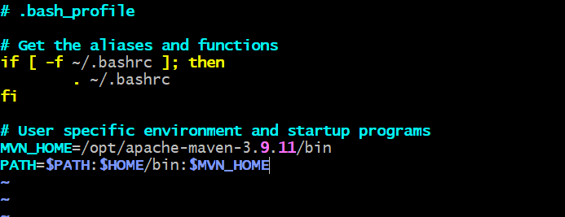
Restart the bash_profile changes will applicable
To restart
(Source ~/.bash_profile)
Mvn --version (Now Maven Version is available)
q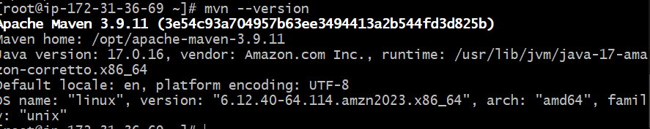

Now say to Jenkins maven is available so and so location
Go to JenkinsManage JenkinsToolsgo to maven
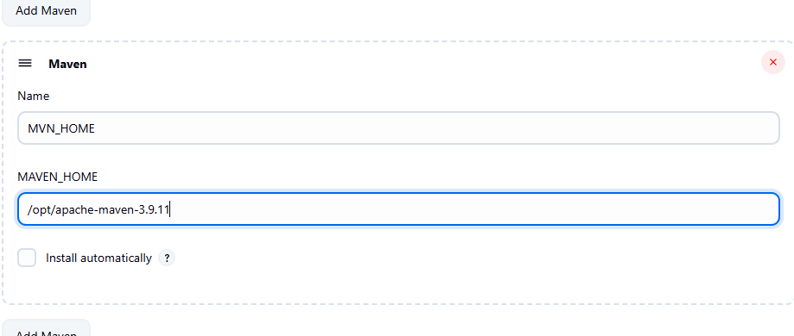
goto job --> add build step --> select invoke top maven -- goals(clean install)
m. Then it will clean and create a package
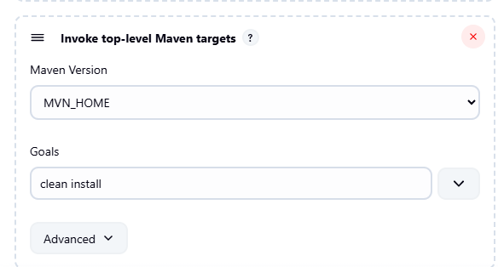
Now run the build then git clone done, sonarqube integration done, then maven
created a war file.

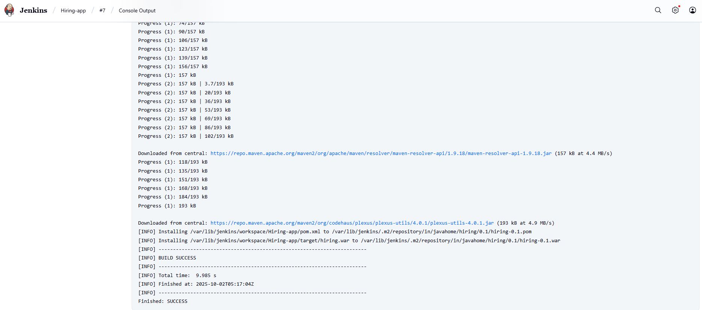
We can find war files
/var/lib/jenkins/.m2/repository/in/javahome/hiring/0.1/hiring-0.1.war
r. In jenkins server → cd /var/lib/jenkins/workspace/hiring-app/target
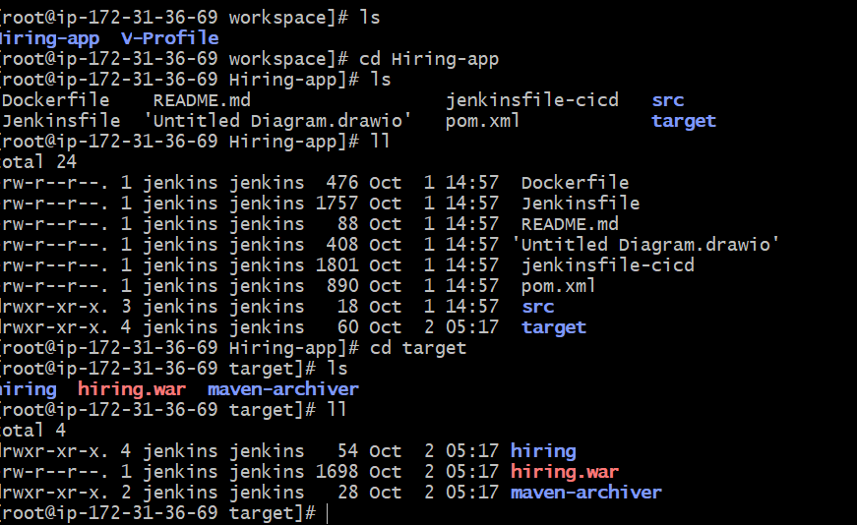
We can check dependencies in jenkins server
Cd /var/lib/jenkins/.m2/repository
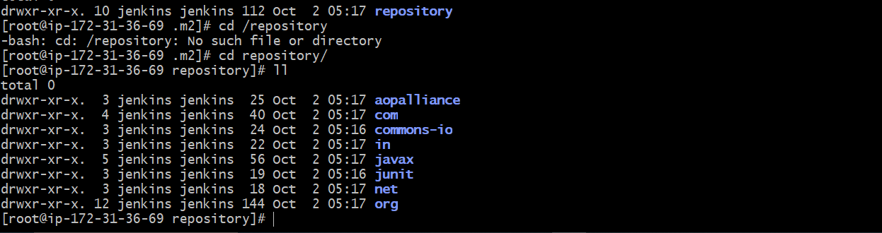
NEXUS ARTIFACTORY: To store Artifacts in Central Location
Now create nexus-ec2 with t2.large
2. Install java → yum -y install java-1.8*
3. And now download nexus
cd /opt
wget https://sonatype-download.global.ssl.fastly.net/nexus/3/nexus-3.0.2-02-
unix.tar.gz
tar -zxvf nexus-3.0.2-02-unix.tar.gz
mv /opt/nexus-3.0.2-02 /opt/nexus
4. In nexus ec2 → cd /opt/nexus/bin
5. Vi nexus.rc
6. Remove # and Add → run_as_user="ec2-user"
7. Now switch to ec2-user give ownership and start and check status.
8. Cd /opt
9. Give permissions → sudo chown -R ec2-user:ec2-user nexus
10. Cd /opt/nexus/bin
11. ./nexus start
12. ./nexus status
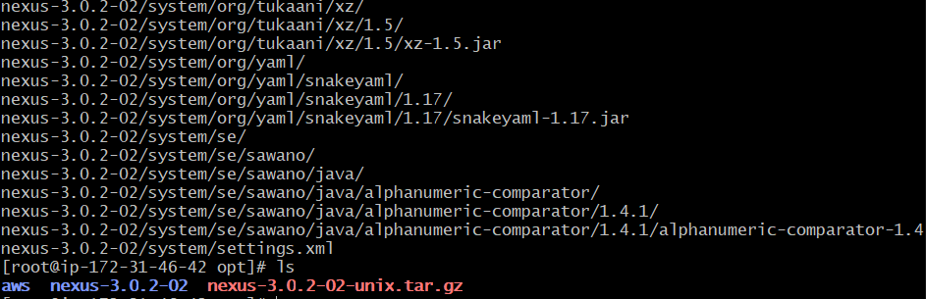
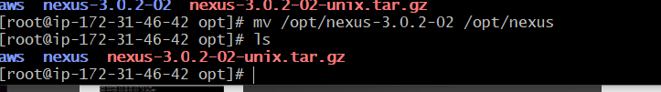
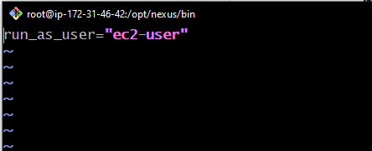
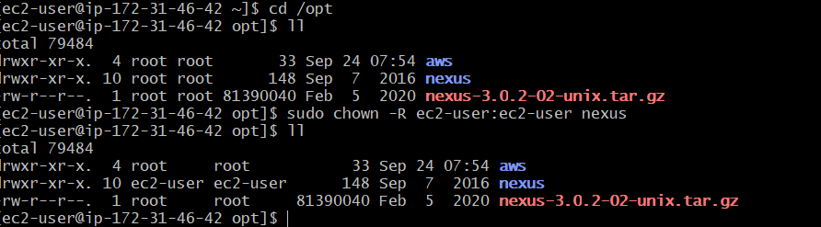
[ec2-user@ip-172-31-46-42 nexus]$ cd bin
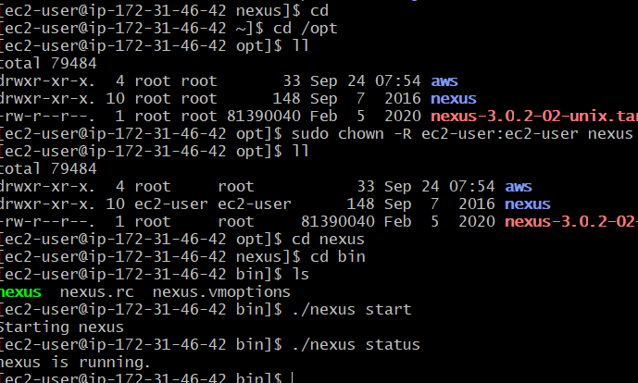
Check in browser with public ip of nexus-ec2 it runs on port number 8081
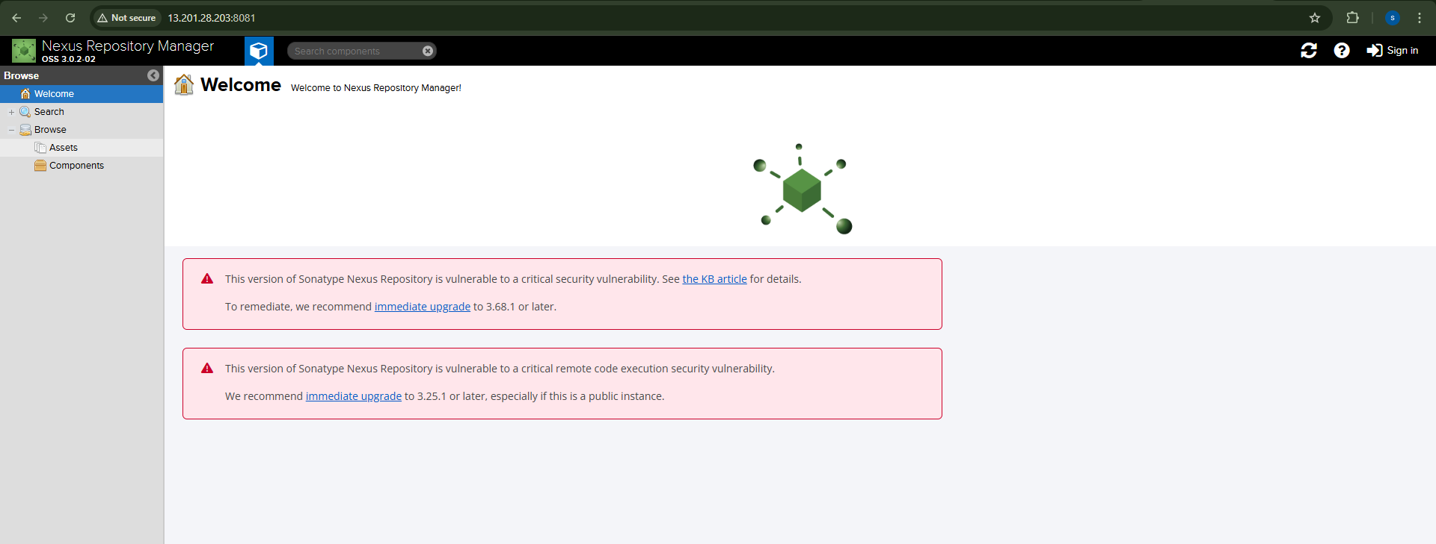
Now sign in with login details → admin , admin123
Integrate jenkins with nexus
1. Download plugin “nexus artifact uploader” in Jenkins
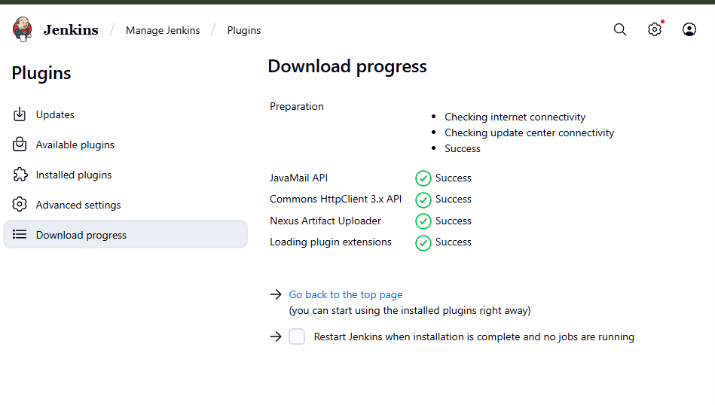
2. Now go to your job → configure → build step → nexus
In git hub repo in pom.xml file we have some info group id and
version, bring and enter here and goto nexus create repository
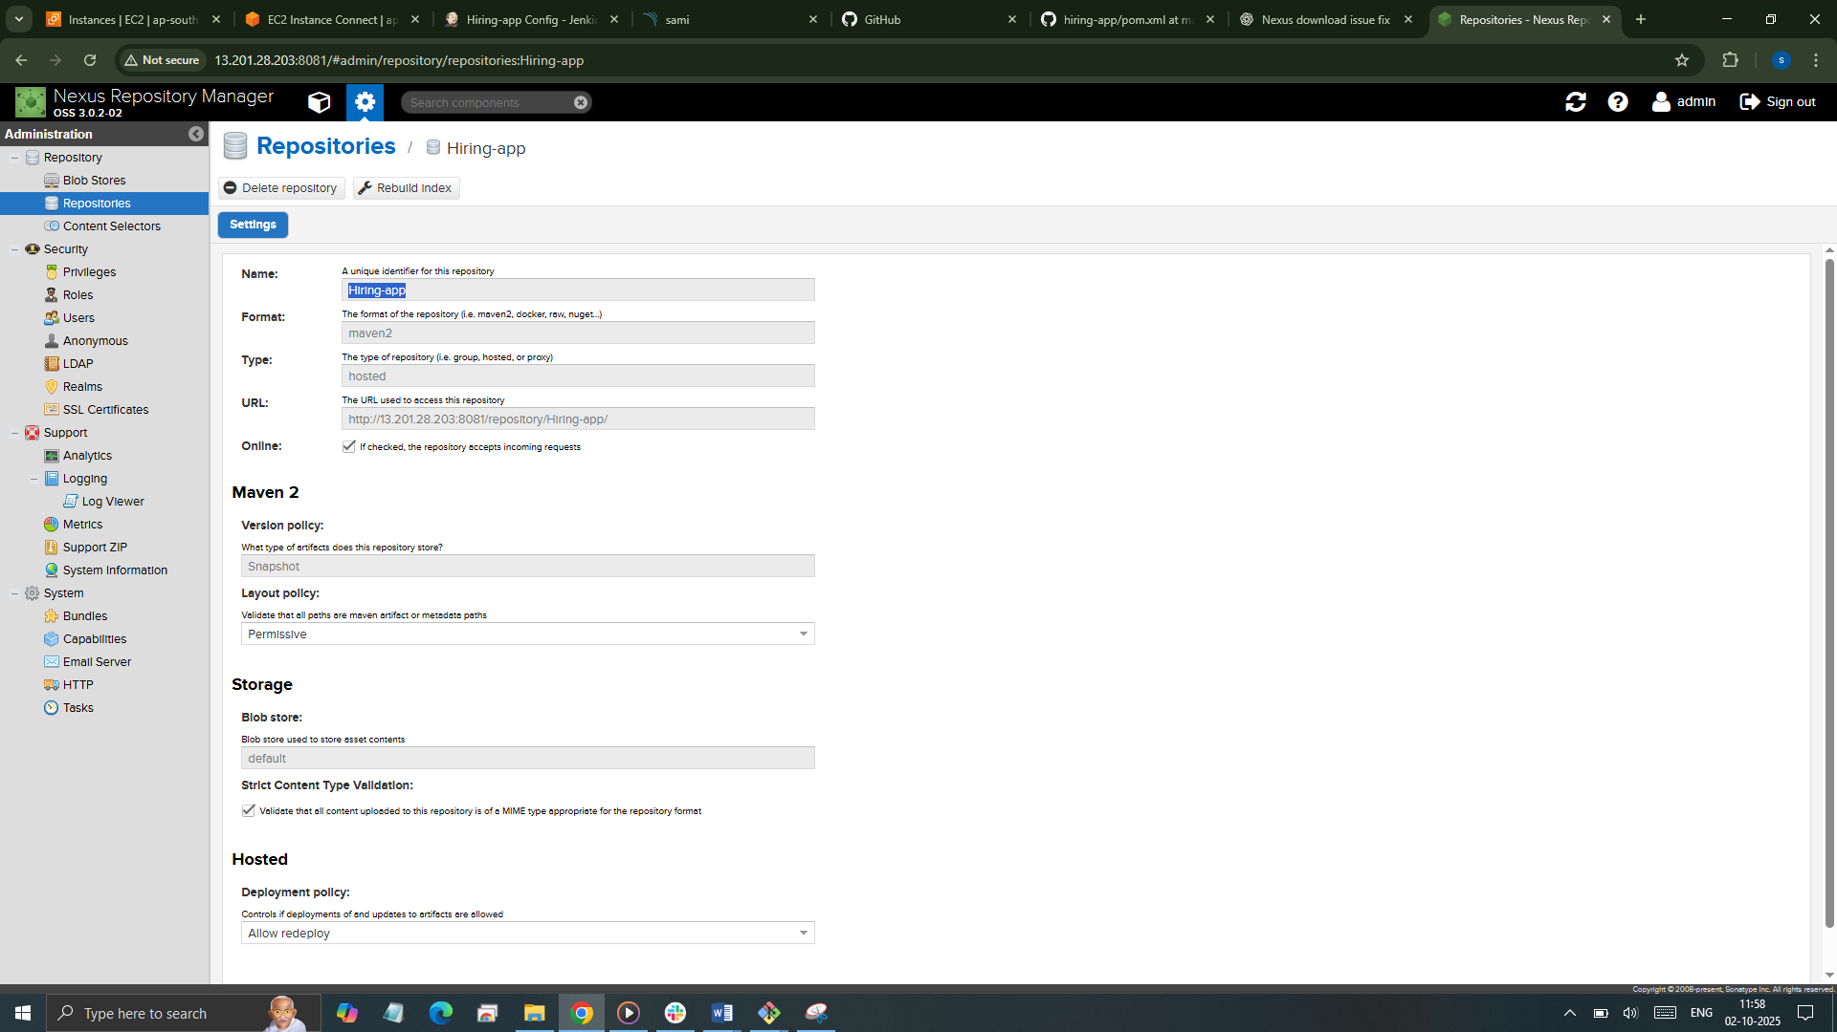
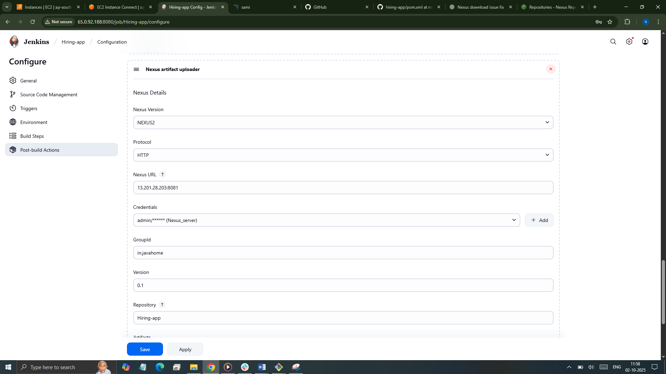
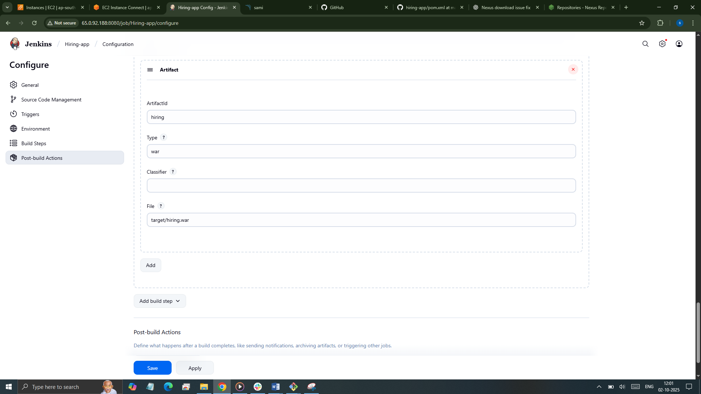
Now run and build
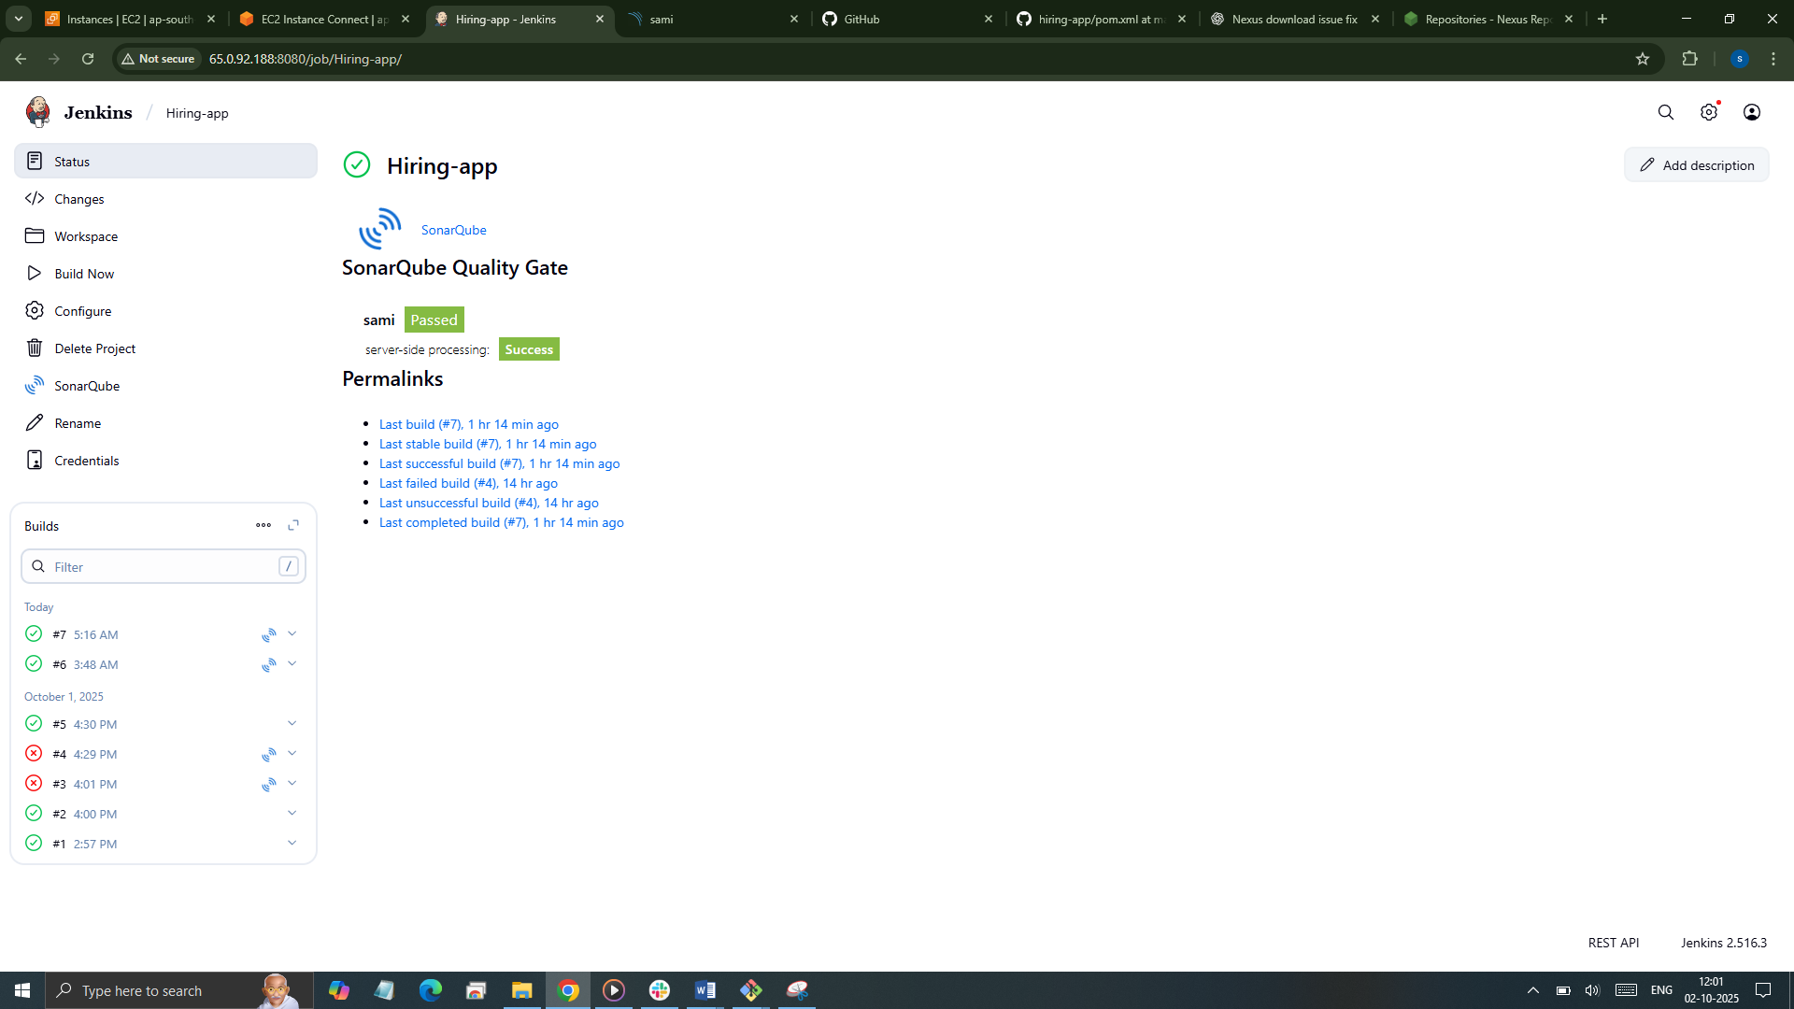
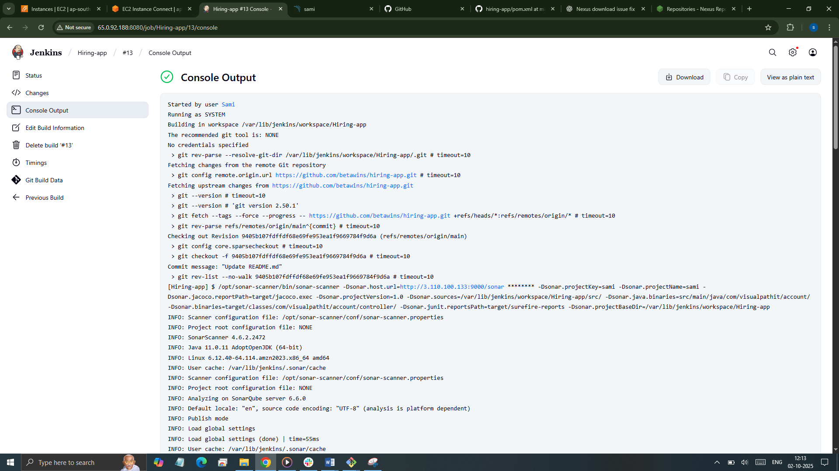
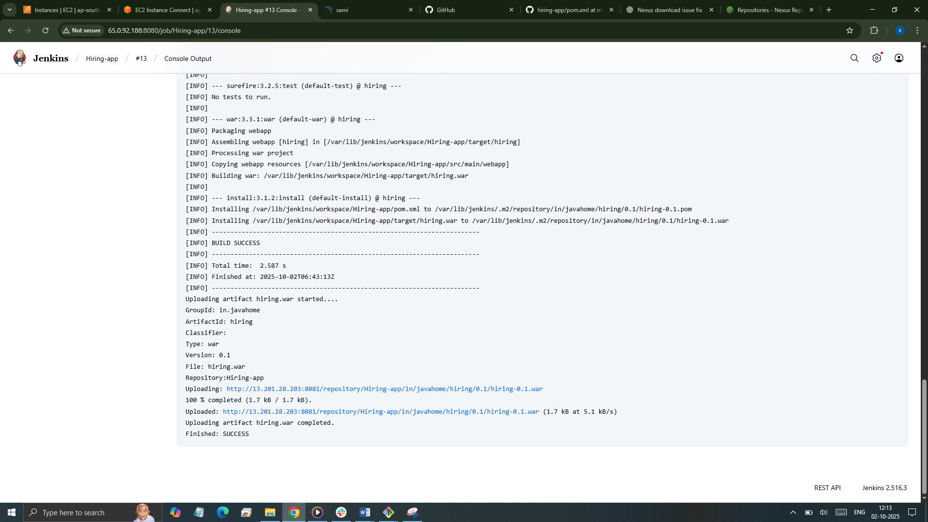

Check in nexus war file
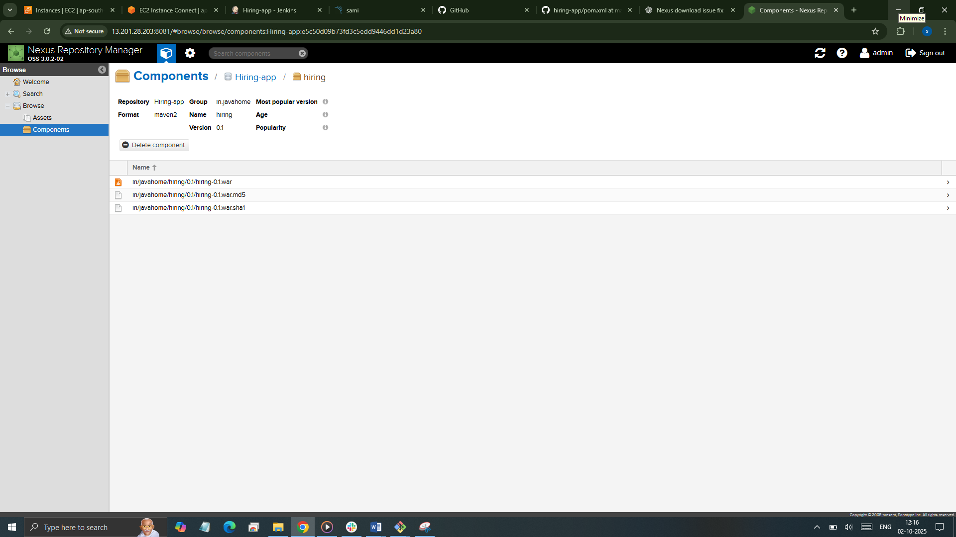

SLACK NOTIFICATION

Go to Jenkins pluginsinstall slack notification
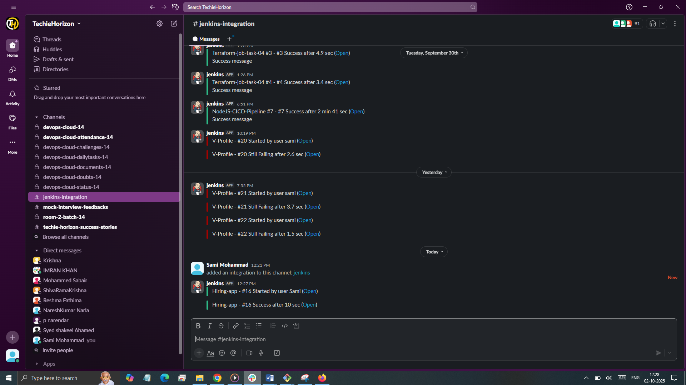

CONTINOUS DEPLOYMENT
DEPLOY IN TOMCAT

- Go to jenkins page Install plugin → deploy to container
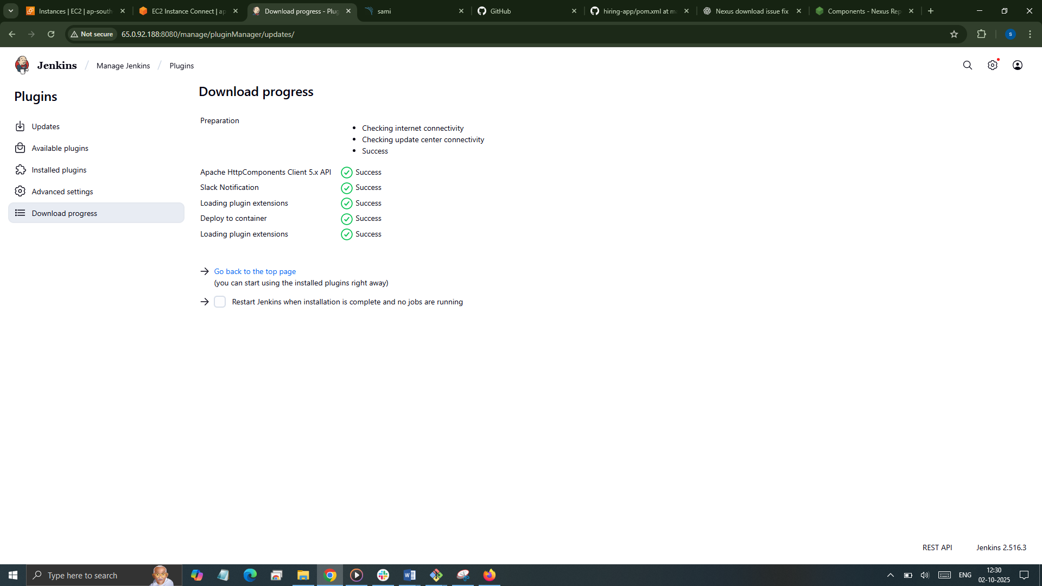

3. Now create tomcat-ec2 and install tomcat.
4. Install java 1.8
Cd /opt
Wget https://dlcdn.apache.org/tomcat/tomcat-9/v9.0.108/bin/apache-tomcat-9.0.108.tar.gz
tar xvf apache-tomcat-9.0.108.tar.gz
sudo mv apache-tomcat-9.0.108 /opt/tomcat
sh /opt/tomcat/bin/startup.sh
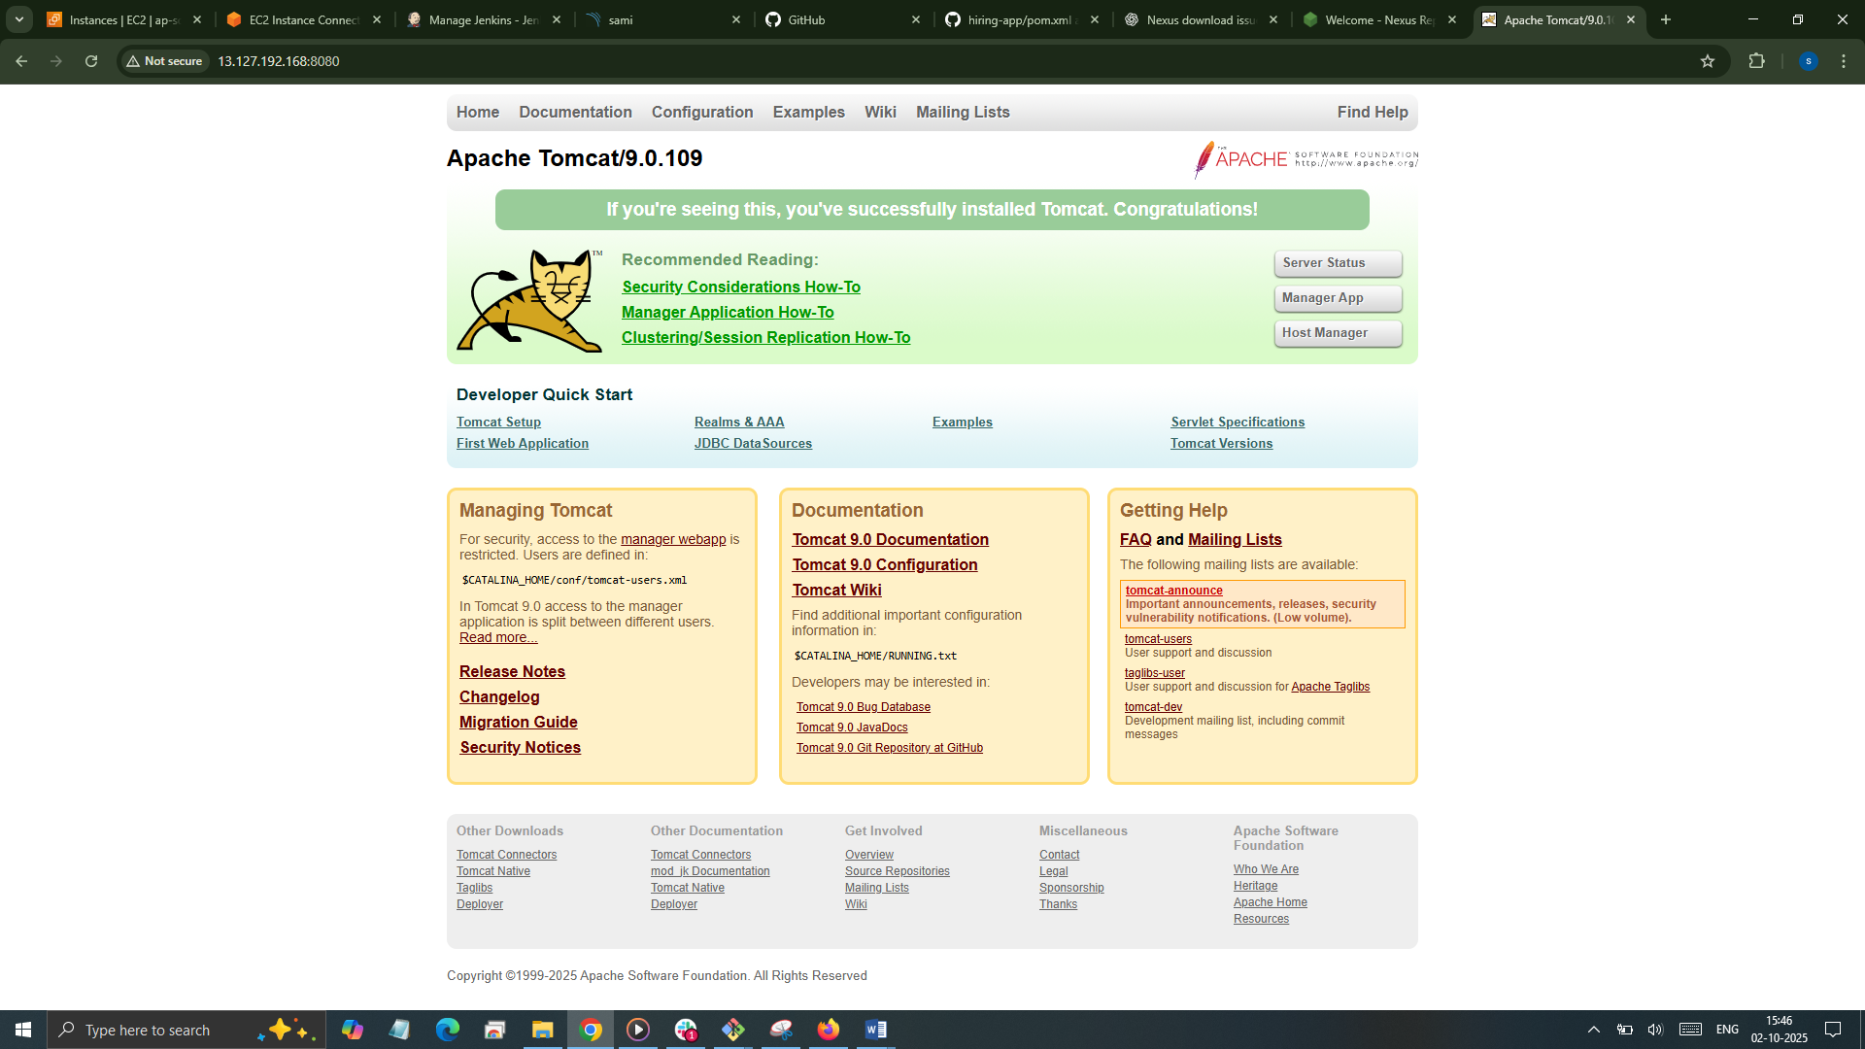
- Now create user in tomcat.
- find / -name context.xml
- Take file webapps and edit for uncomment the four files
- Vi /opt/tomcat/webapps/docs/META-INF/context.xml

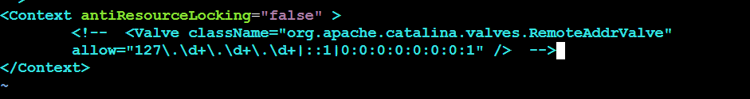

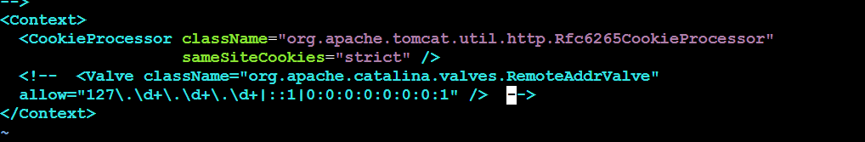

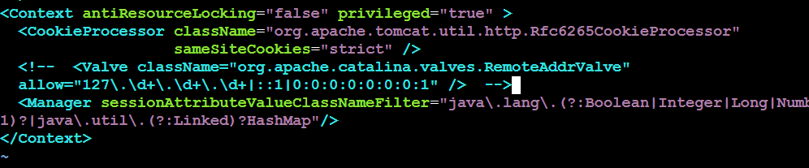

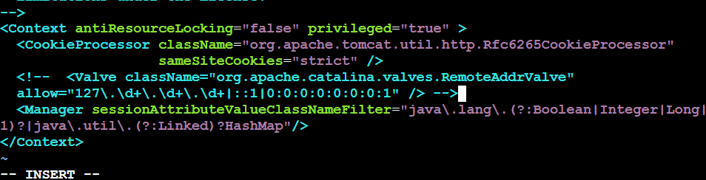

17. Now goto conf in xml file add the below user details as shown in box.

Cd /opt/tomcat/conf
vi tomcat-users.xml

<role rolename="manager-gui"/>
<role rolename="manager-script"/>
<role rolename="manager-jmx"/>
<role rolename="manager-status"/>

<user username="admin" password="admin" roles="manager-gui,manager-script,manager-jmx,manager-status"/>
<user username="deployer" password="deployer" roles="manager-script"/>
<user username="tomcat" password="s3cret" roles="manager-gui"/>

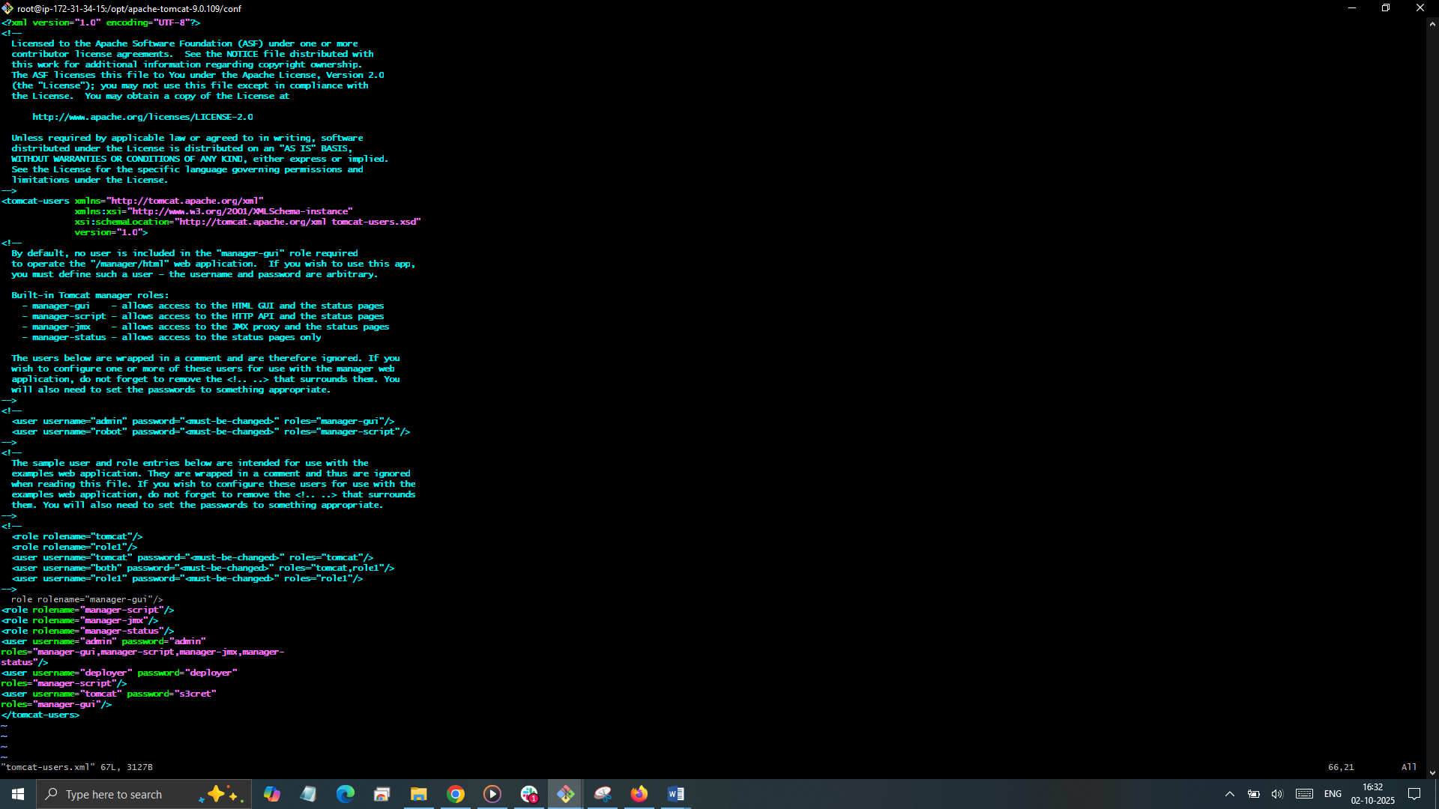

- sh /opt/tomcat/bin/shutdown.sh
- sh /opt/tomcat/bin/startup.sh
- Now in web page click on server status
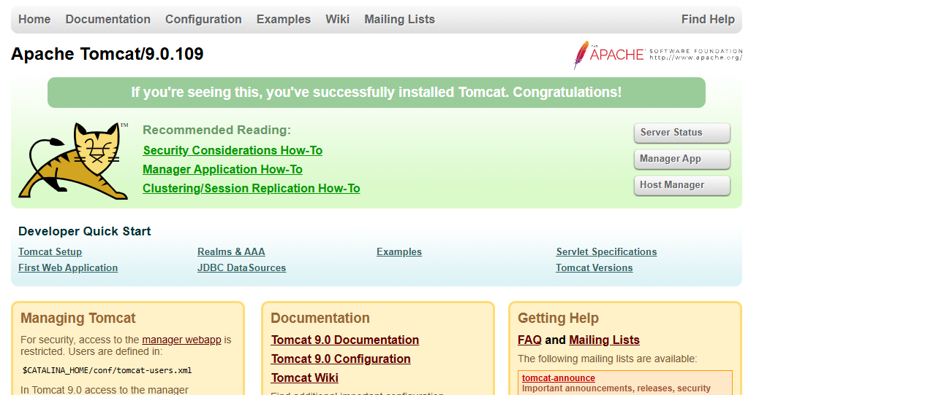
- Enter user deployer , password deployer
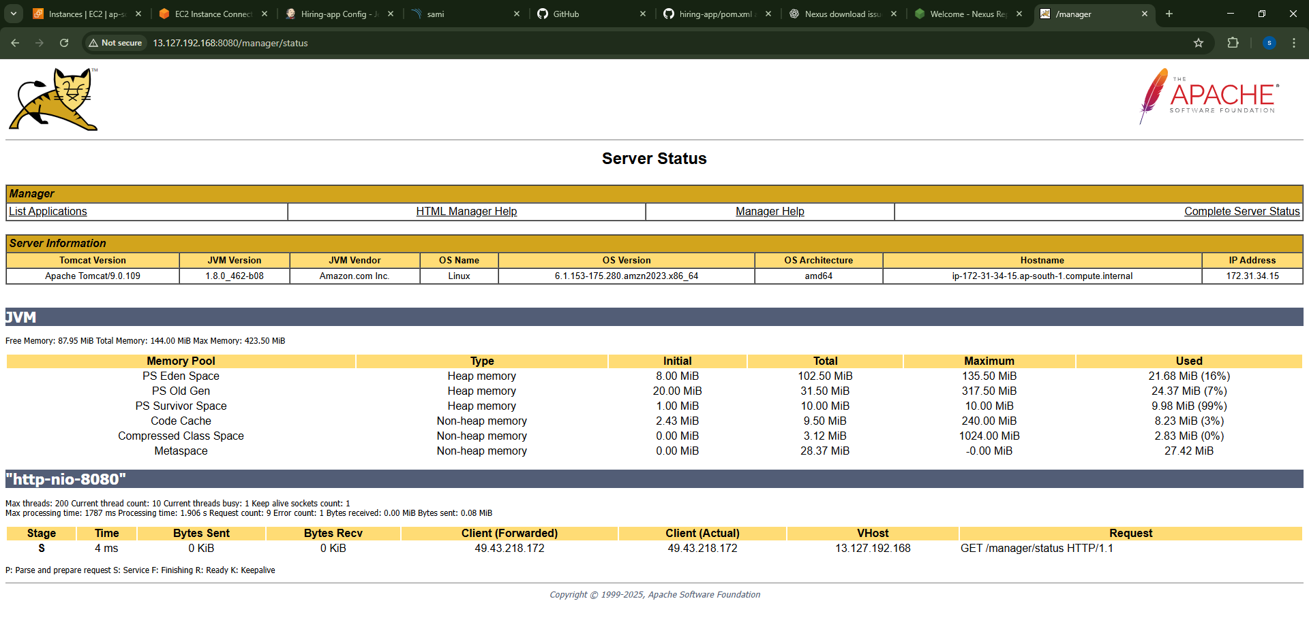
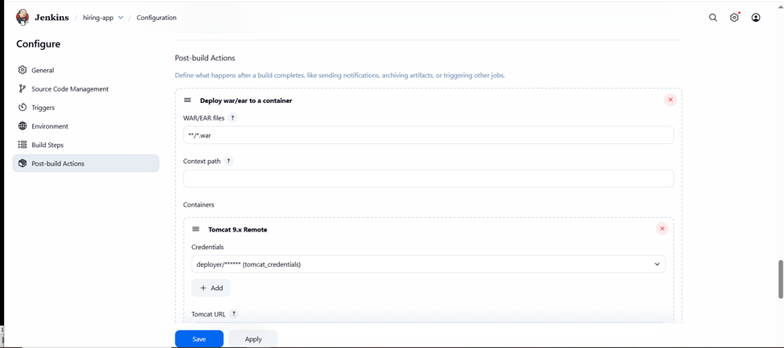
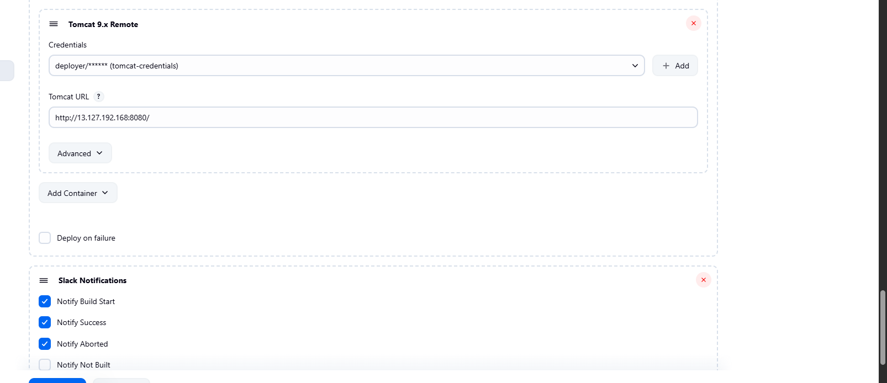

Now Build
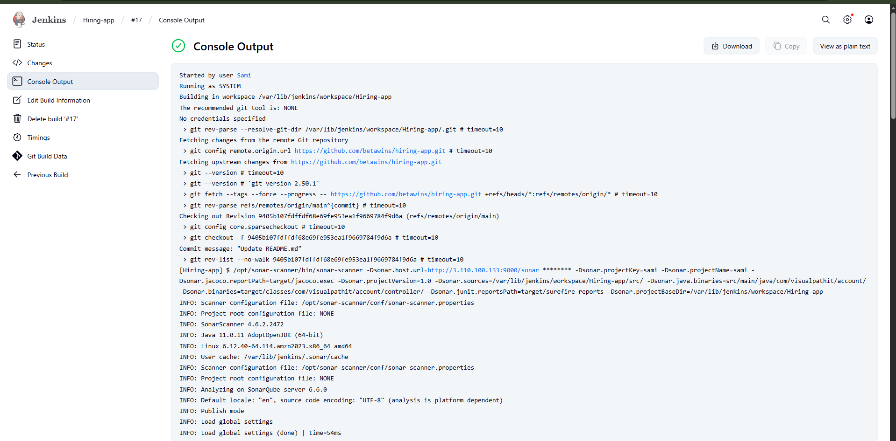
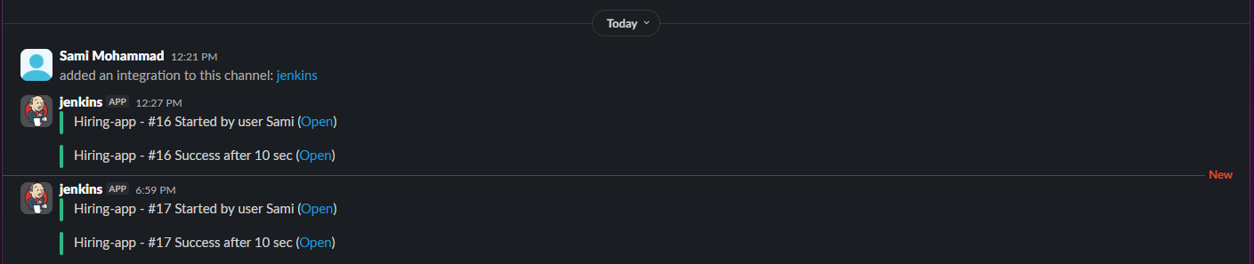
- Now our deployment successfully done
- Now you can check in tomcat cli webapps one file is shown
- Cd /opt/tomcat/webapps/hiring
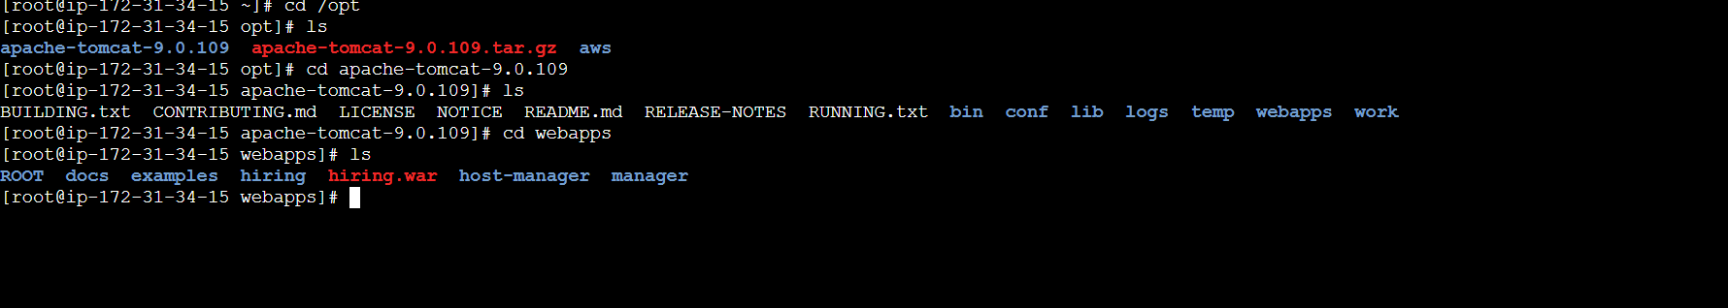

- And you can check in tomcat at browser we got our application is live.
- http:// 13.127.192.168:8080/hiring/
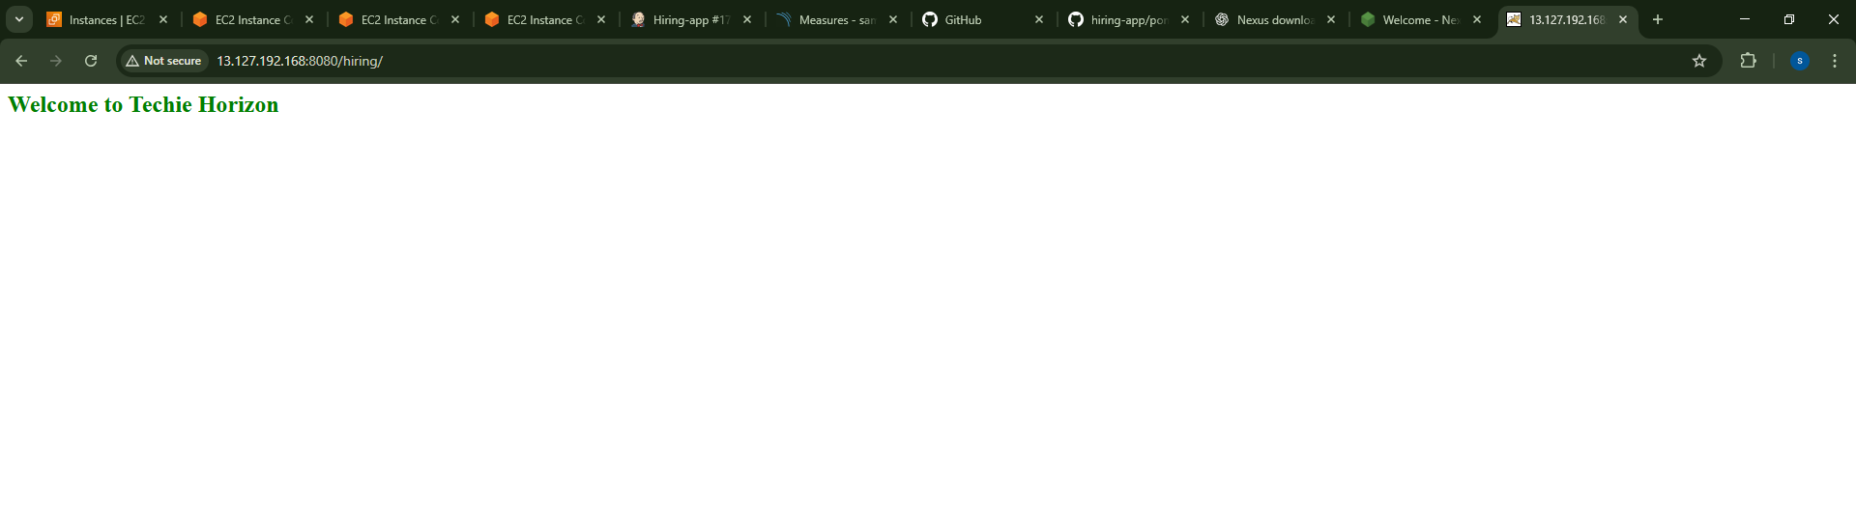
- And you can confirm the content by checking git repo code.

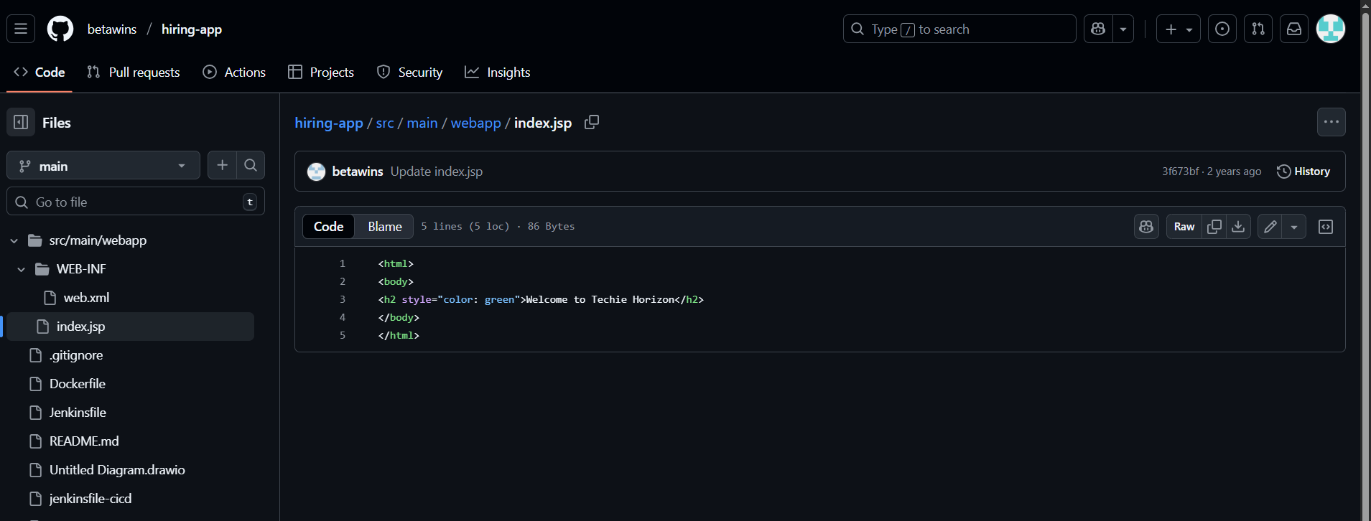

2) Setup a jenkins CICD pipeline using Declarative pipeline using feature-1.1 branch.
https://github.com/betawins/sabear_simplecutomerapp/tree/feature-1.1
stages:
1) Git Clone
2) Sonarqube Integration
3) Maven Compilation
4) Nexus Artifactory
5) Slack Notification
6) Deploy On tomcat

Ensure the following plugins are installed:
• Pipeline (for both Declarative and Scripted)
• Pipeline Utility Steps (for readMavenPom, findFiles, etc.)
• Nexus Artifact Uploader
• SonarQube Scanner for Jenkins
• Slack Notification

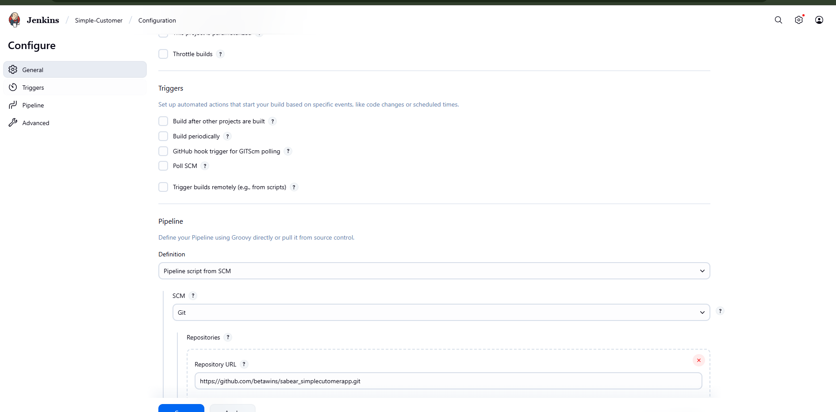

Pending
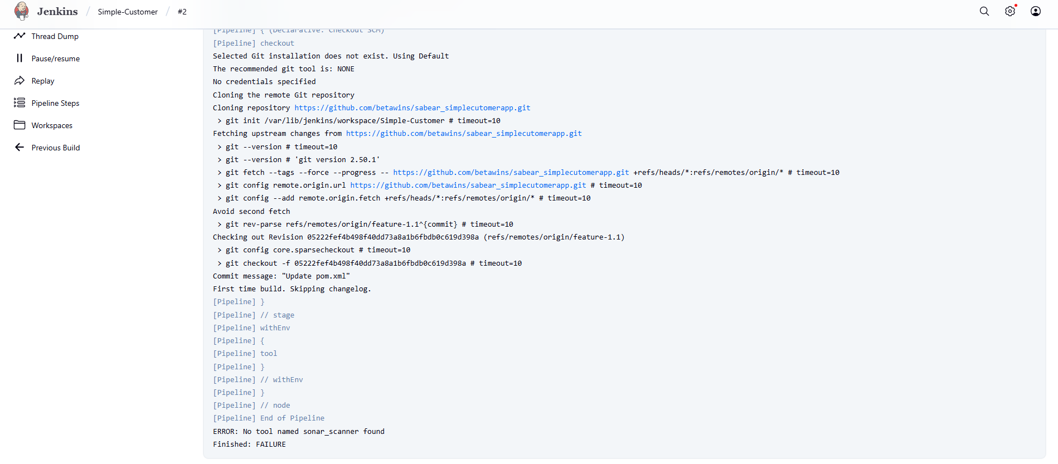

4) Write sample skeleton of pipelines.
1. Declarative Pipeline

pipeline {
agent any // run on any available agent

environment {
// define environment variables here
APP_NAME = "myapp"
}

options {
skipStagesAfterUnstable()
timestamps()
}

stages {
stage('Checkout') {
steps {
echo "Checking out source code..."
checkout scm
}
}

stage('Build') {
steps {
echo "Building application..."
sh 'mvn clean package -DskipTests'
}
}

stage('Test') {
steps {
echo "Running tests..."
sh 'mvn test'
}
}

stage('Deploy') {
steps {
echo "Deploying application..."
sh 'kubectl apply -f k8s/deployment.yaml'
}
}
}

post {
always {
echo "Pipeline finished. Cleaning up..."
}
success {
echo "Pipeline completed successfully 🎉"
}
failure {
echo "Pipeline failed ❌"
}
}
}

- Scripted Pipeline
node {
// Define environment variables
def appName = "myapp"

try {
stage('Checkout') {
echo "Checking out source code..."
checkout scm
}

stage('Build') {
echo "Building application..."
sh "mvn clean package -DskipTests"
}

stage('Test') {
echo "Running tests..."
sh "mvn test"
}

stage('Deploy') {
echo "Deploying application..."
sh "kubectl apply -f k8s/deployment.yaml"
}

echo "Pipeline completed successfully 🎉"
}
catch (Exception e) {
echo "Pipeline failed ❌ : ${e.message}"
currentBuild.result = 'FAILURE'
throw e
}
finally {
echo "Cleaning up workspace..."
cleanWs()
}
}

